Seasons greetingsseasons greetings

The Swimming Pool
Jan/Feb 2021
Issue 128



Newsletter for the
SWIMS Network
The Editorial Team

Katie Barnard

Sam Burgess

Pam Geldenhuys

Lucy Gilham

Jessica Pawley

Inside this issue

Reflections on an IoW virtual library showcase 2

Public Health Bulletin one year on – resurrection! 3

Welcome to a new apprentice 3

Art Attack at North Bristol Trust 4

Intra-lending is soon to launch…. 8

#UKmedlibs: the February chat 9

Gloucestershire team in 3 counties and 2 countries! 9

Editorial Team Details 10

Reflections on an Isle of Wight virtual Library Showcase day
Anne Lancey, Isle of Wight

Mentioning in a meeting in how much I had enjoyed the LKS Live event (wallowing in libraryland for a few hours), I immediately spotted ideas bubbles rising from my boss’s head and next thing I was agreeing to organising such a programme internally to promote the library! There had also been a bright idea to make 2021 a ‘Year of Learning’ with the teams within the Education Training & Development department each taking a month to promote themselves - ‘Libranuary’ seemed apt, which meant the ‘virtual library showcase’ needed to be advertised in December and further procrastination was not possible.

Against our natural introvert tendencies the library team took a deep breath and each stepped up with a section they could present, the programme was fixed for 12th January, and advertised on the Trust e-bulletin – no turning back. Christmas came and went, presentations were hastily put together about our different resources and services and a few trials on Teams calmed nerves – fortunately we have the MSTeams guru, in the library team…

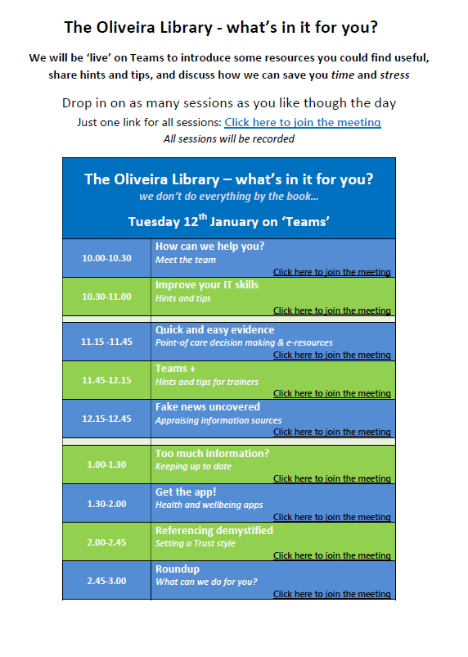
The event (10am-3pm) ran very smoothly, with a single MSTeams link for the whole event allowing staff to drop in on sessions as able. The library resource sessions were interspersed with lighter and more interactive IT sessions, which worked well. Unfortunately we only had 8 staff join us, with the MS Teams presentation being most popular. However, we all felt that we had learnt quite a bit ourselves from each other’s presentations, and about using Teams for training and such events. We did record the sessions, and plan to make them available through our website, along with the Powerpoint presentations – but first we need to review the recordings, and quite possibly re-do them…!

As you may have gathered, our main failure was in publicising – the initial advert had gone out, but unfortunately we had not managed to get another advert in the e-bulletin since, and otherwise just a couple of posts on the Trust Facebook page (a new skill!) and our library Twitter account.
A last minute message out to the Working from Home Network by a helpful ETD team member proved most useful though! In addition we had been keen to offer an incentive, but failed to decide on it early enough and to publicise it and the joining link sufficiently. Of course the timing, just as the rise in Covid cases and admissions was beginning, meant that we knew clinical staff would be unlikely to be able to join.

However, our overall reflection was positive – we were not nearly as tired as expected by the end, had enjoyed some conversations with staff joining during the day, extended our own knowledge, and definitely felt quite a sense of achievement. It is certainly something we feel we could repeat, as well as making more use of short recordings and Teams sessions in our training plans, and advertised open Teams sessions for LKS queries and discussion. We just need to crack the publicity and promotion game!

Anne Lancey, LKS Manager, Isle of Wight (IoW)
Public Heath Bulletin one year on - plans for its resurrection!

Back in March 2020 the team who were producing the Public Health Bulletin decided it would be better to focus on supporting our clinical colleagues with keeping them up-to-date on this strange new corona virus which had thrown the world into turmoil.

Now that things have settled down we’ve been thinking it’s time to get it restarted and are looking for new additions to the team, possibly extending its circulation further into the South West.

So wherever you’re based, if you have an interest in Public Health, local involvement with your public health colleagues or want to add variety to or develop your current role then this may be what you’re looking for! You will receive training on producing the Bulletin, on a rota basis, following straightforward guidelines and a template, and the opportunity to work with a small friendly team of library staff.

You can see previous editions of the Wessex Bulletin at http://www.wessexphnetwork.org.uk/resources/public-health-bulletin.aspx to give you an idea.

We will be having a virtual meeting in the next 3-4 weeks, or if you have any questions in the meantime please contact Liz Land at H34 (elizabeth.land@hhft.nhs.uk ). We look forward to welcoming you!

Liz Land
Knowledge Specialist
Hampshire Hospitals NHS FT (H34)
Welcome to a new apprentice!

Hello! My name is Jasmin, I’m the new Apprentice Library Assistant at GRH & CGH.
I am fresh from the trenches of university (having completed a degree in Philosophy), and ready to take on my new role as an NHS Library assistant. I’ve been working in public libraries for 5 years now, so, it seems I cannot escape libraries (or rather libraries cannot escape me!). But I am keen to see how NHS libraries differ from my usual stomping grounds.
A brief 'about me' just to give a person behind the name tacked onto emails. I am an aspiring ‘plant mum’. Having successfully kept a spider plant alive for a year; I have graduated to a terrarium with various succulents. All of which seem to be doing well, fingers crossed.
Beside plants, I like sewing, embroidery and a dash of illustration.
I hope this gives a small inkling into the new name popping up on emails. And I am just happy to be working with such a welcoming team. Surrounded by such lovely people, I'm already loving my time here. And I'm certain it will only improve!

Jasmin Habgood
Apprentice Library Assistant
Gloucester Royal Hospital and Cheltenham General Hospital (GRH/CGH)

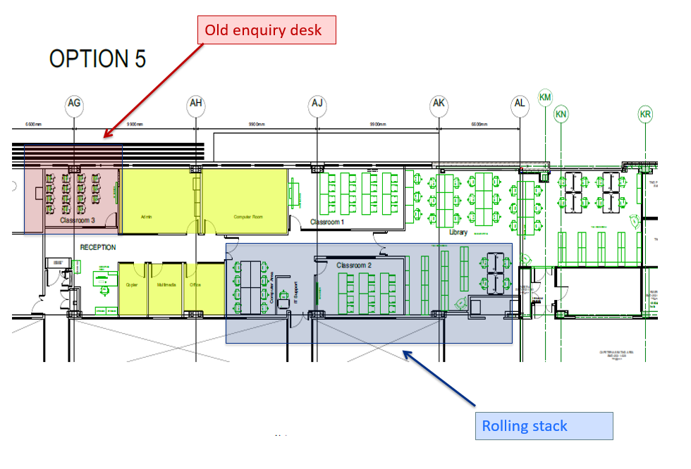
Art Attack at North Bristol Trust
John Loy, Bristol

We’re very lucky here at North Bristol Trust as we have a vibrant arts programme, co-ordinated by three very dedicated individuals in the Fresh Arts team (https://www.nbt.nhs.uk/fresh-arts) . The Trust recognises that creativity and the arts make a positive difference to patients, visitors and staff wellbeing and we enjoy a real range of things from art on the walls to creative writing workshops and live music – though that is currently in the form of lunchtime concerts online via zoom on a Wednesday.

When I joined the Trust in 2016 the Fresh Arts folks were supportive in helping us turn one of the walls within the library into a gallery space. Since then we’ve enjoyed a real selection of work – watercolours, screen prints, photography, textiles - with our guest artists changing three or four times a year in the library gallery.

Adding art was comparatively easy to do, but my major challenge was reconfiguring the wider library environment. We have the luxury of space for the library here at Southmead, housed within the Learning and Research Building which opened in 2010. This was a new build as part of the merger of services from the Frenchay and Southmead sites, and the library was designed to accommodate the print holdings from the two libraries. This largely took the form of a huge rolling stack to accommodate many years’ worth of print journal archives. Jump forward a few years and having around a third of the floorspace taken up by a print archive was more than a little old-fashioned. Our library had lots of room for shelving but a lessening need for print resources, both book and journal, to go on them. We could make such better use of the library footprint, and create a more welcoming space for people with less emphasis on stuff.

Jump forward to 2020 – we’ll skip over the many, many meetings where “how will it be funded?” brought things to halt – and the need to accommodate extra medical students onsite finally brought funding which could be used to redevelop the space. We ripped out the rolling stack and the existing enquiry desk, both well-intentioned in 2010 but dated by 2020, and were able to use the space for three new classrooms. We also ensured that the business case included £50K for electronic journal archives; the print journals were gone and the content became more easily available online.

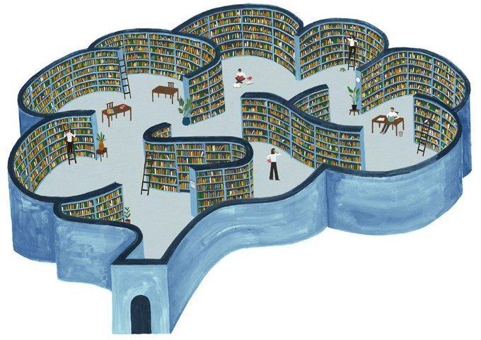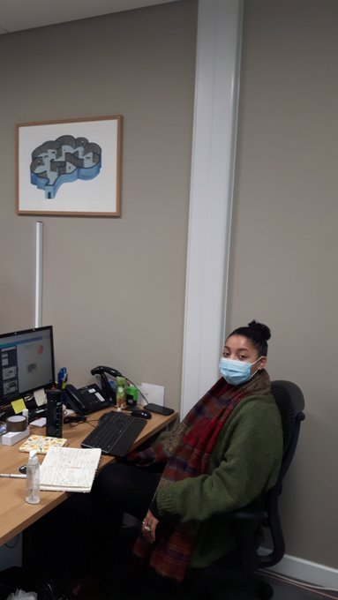
So for three months, from August to November, the library was a building site, but once the builders were out we could move on to the more aesthetically pleasing side of things. I had always planned to have some large-scale artworks on the walls, and our great Southmead Hospital Charity (https://www.southmeadhospitalcharity.org.uk/ ) was equally enthusiastic to support the plan and fund local artists to create some beautiful things for us. We were able to invite back some of our favourite artists who had exhibited in the library gallery since 2016.

Gordy Wright - http://www.gordywright.com/

Gordy Wright was the very first artist we featured in our library gallery in the summer of 2016. At that time he was not long out of university, having completed an arts degree at the University of the West of England and was working part-time here in medical records at Southmead. Fast forward five years and he has firmly established his career; his style has evolved and he and is now working full-time as an illustrator. In 2018 he designed the covers for The Lancet Neurology and this sparked the idea that we might commission him to create something special for us. We’ve christened it the Library Brain, and it graces the space over the enquiry desk. There has been interest from several library users interested in buying a copy, and so if you want your own library brain you can order copies via Gordy’s website.

Sophie Long - https://sophielongart.co.uk/

Bristol has become quite a centre for street art over the last few years, and in normal times there is the annual UpFest, the Urban Paint Festival which happens just south of the river in and around Southville and Bedminster. For one glorious weekend the streets are jam-packed as artists arrive from across the globe to transform buildings and paint temporary billboards. Some are vast, and you may have seen the 5-storey high Greta Thunberg mural (https://tobaccofactory.com/greta-thunberg-mural/) by Jody on the side of the Tobacco Factory.

I have worked as a volunteer marshal at a couple of the Upfests and on the heels of this we commissioned Sophie Long to create some largescale pieces for the library. Sophie has a distinctive “dribbly animals” style which is instantly recognisable, and you’ll see her work on buildings across the city. She’s well-used to largescale works so we decided to go big and her magnificent 2 metre square kingfisher is the first thing you see when you enter the library. It was such a large piece it had be assembled in situ. The kingfisher is accompanied by four one metre square bees, very much Sophie’s trademark, which come with an ecological message.

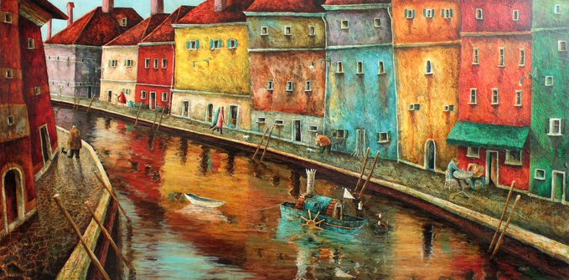
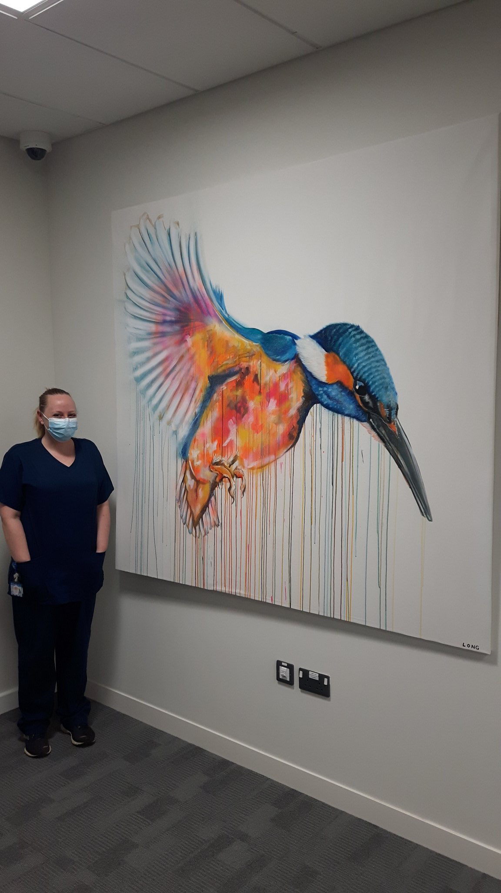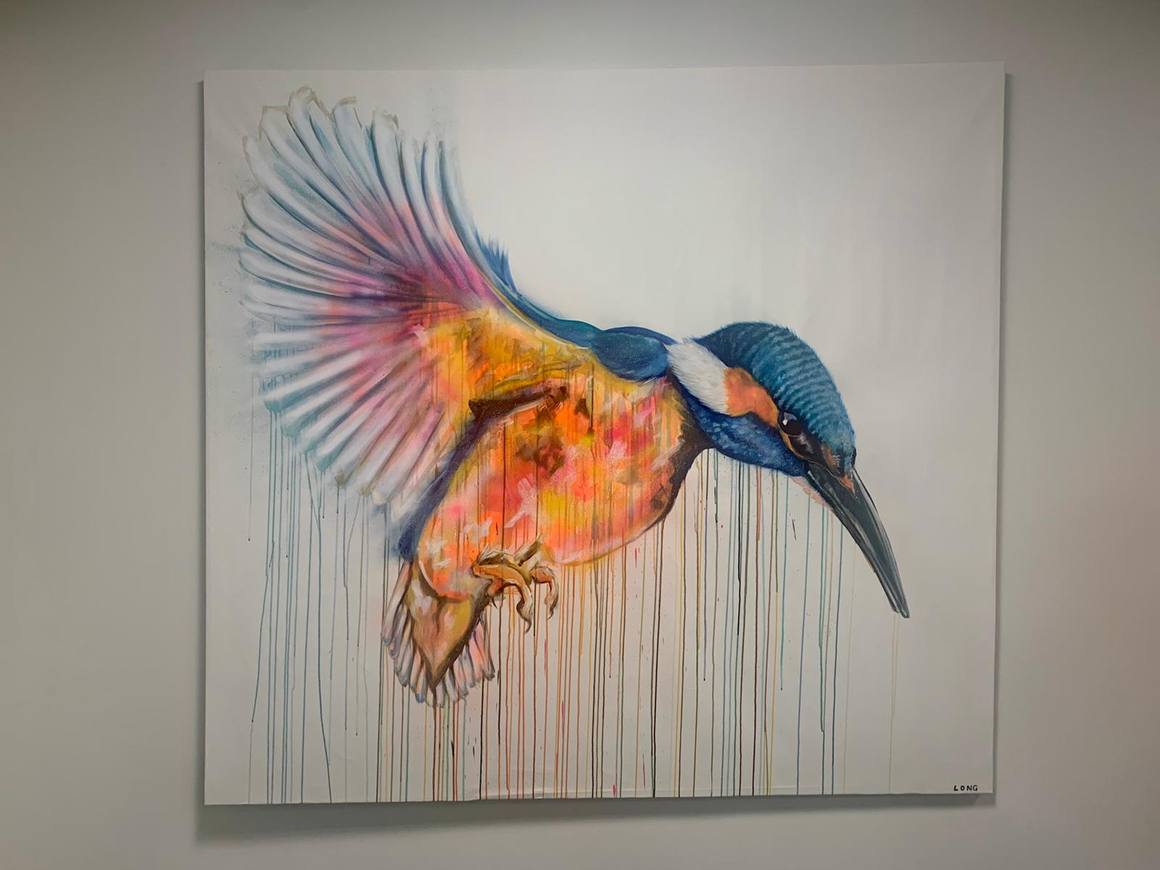

(The nurse by the kingfisher is Jude Clipsom, featured on many news reports in Dec 2020. Jude was the person to administer the first COVID vaccine here in Bristol on 8th December)

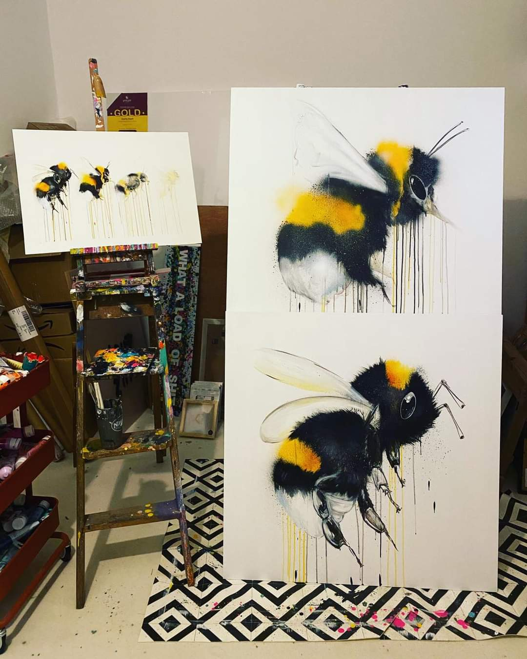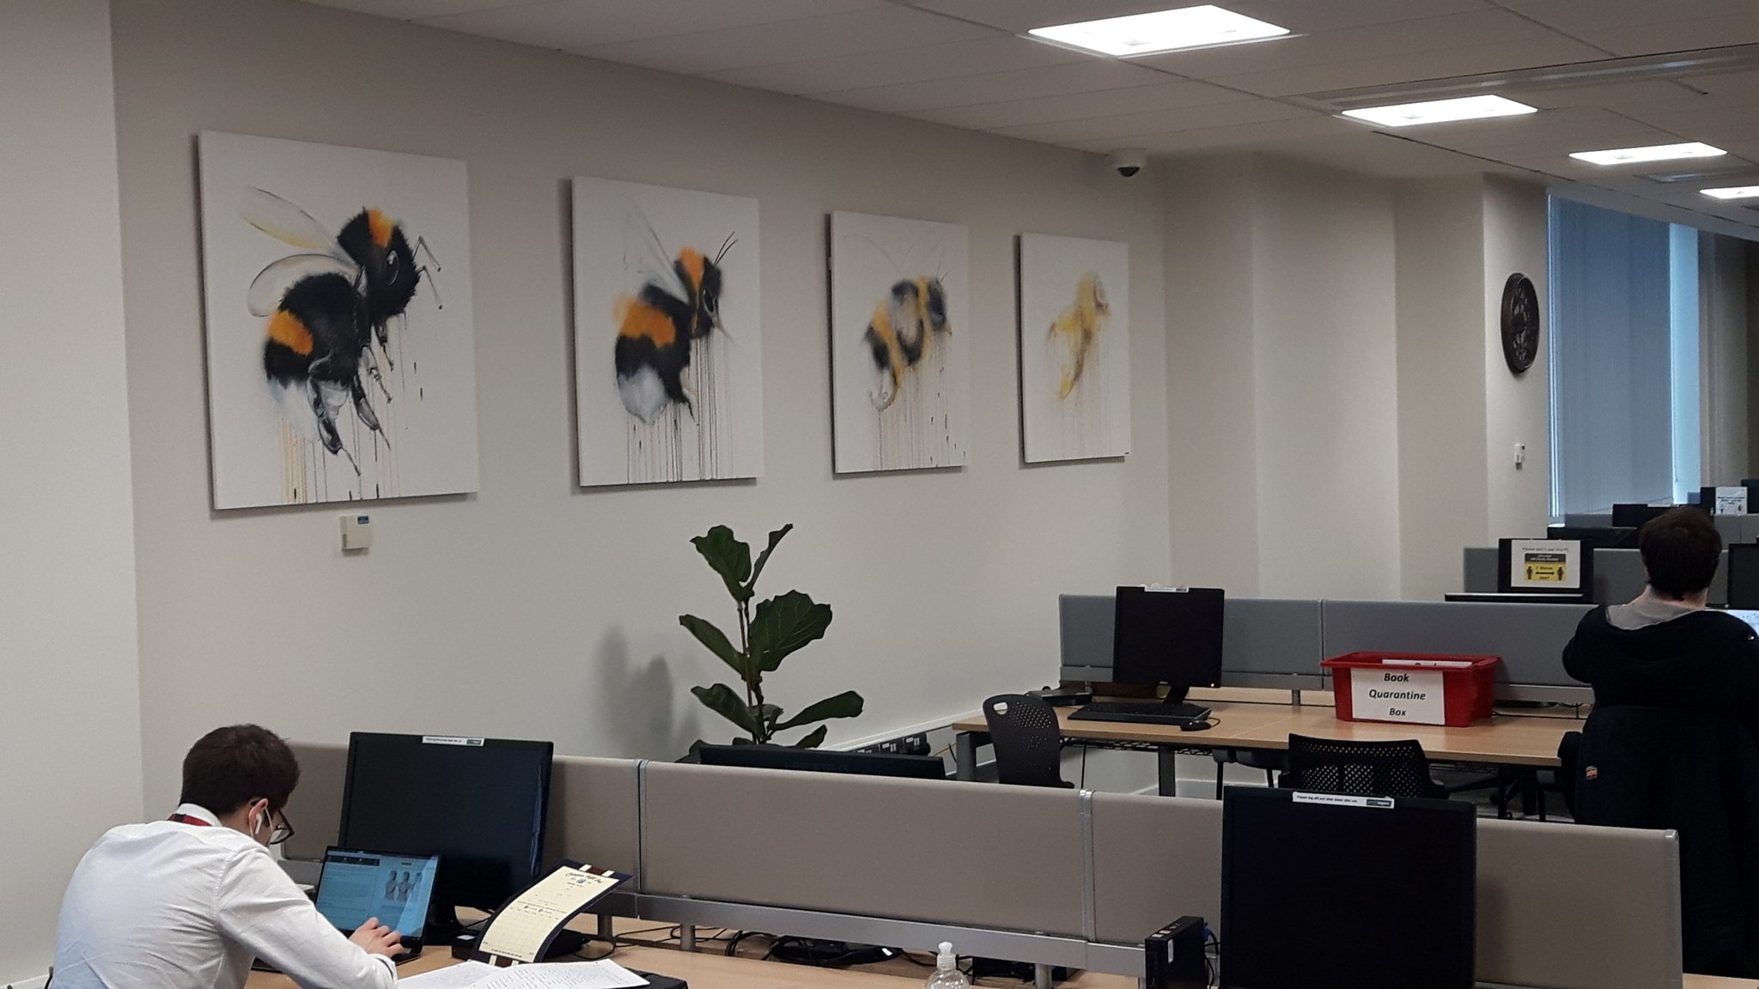
Adrian Sykes - https://www.adriansykes.co.uk/

Adrian is the one exception in that we haven’t ever managed to feature his work in the library gallery. We’ve had discussions but the timing has never quite been right, and while I’ve been a fan of his work I’ve had to make do with a small print over my desk. Adrian is part of an artist collective, based at the Jamaica Street Studios (https://www.jamaicastreetstudios.co.uk/) “one of the largest artist-led studios outside of London” and we have welcomed a couple of his colleagues to exhibit in the gallery space here. As a brief aside, one of his works has been transformed into a huge 5 metre high 3D mural in Birmingham. We couldn’t quite run to that, but instead have a print of his piece Canal Life – inspired by a trip to Venice – blown up to several times its original size. It makes our hot-desking area an infinitely nicer place to be.

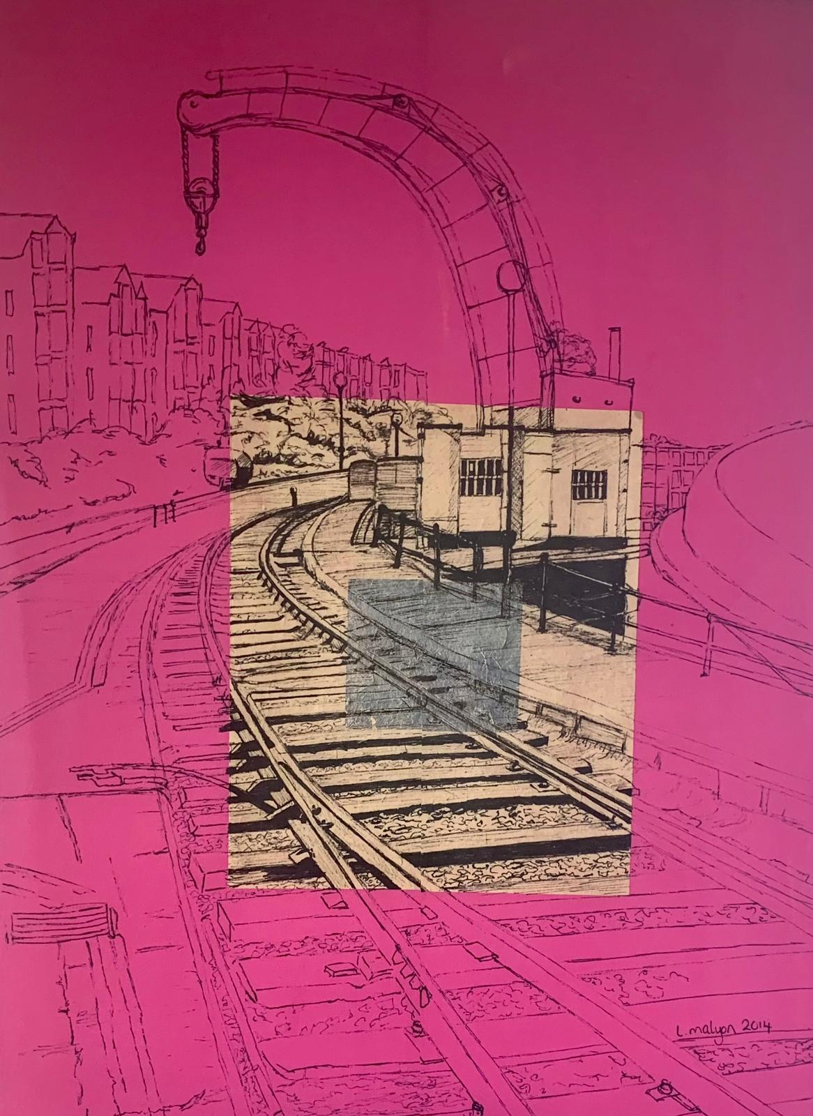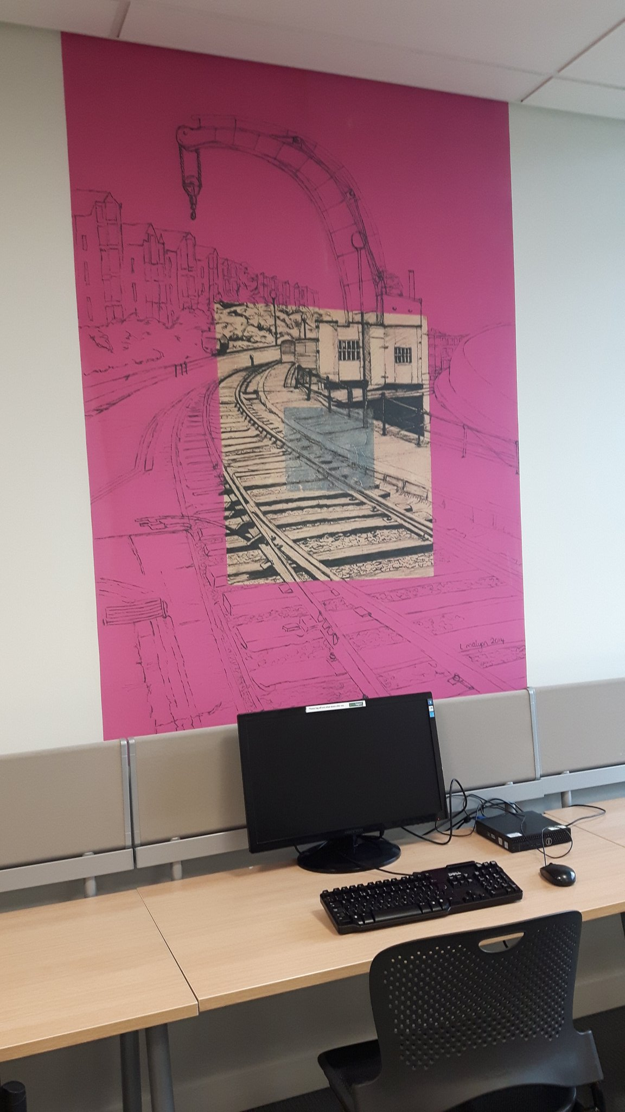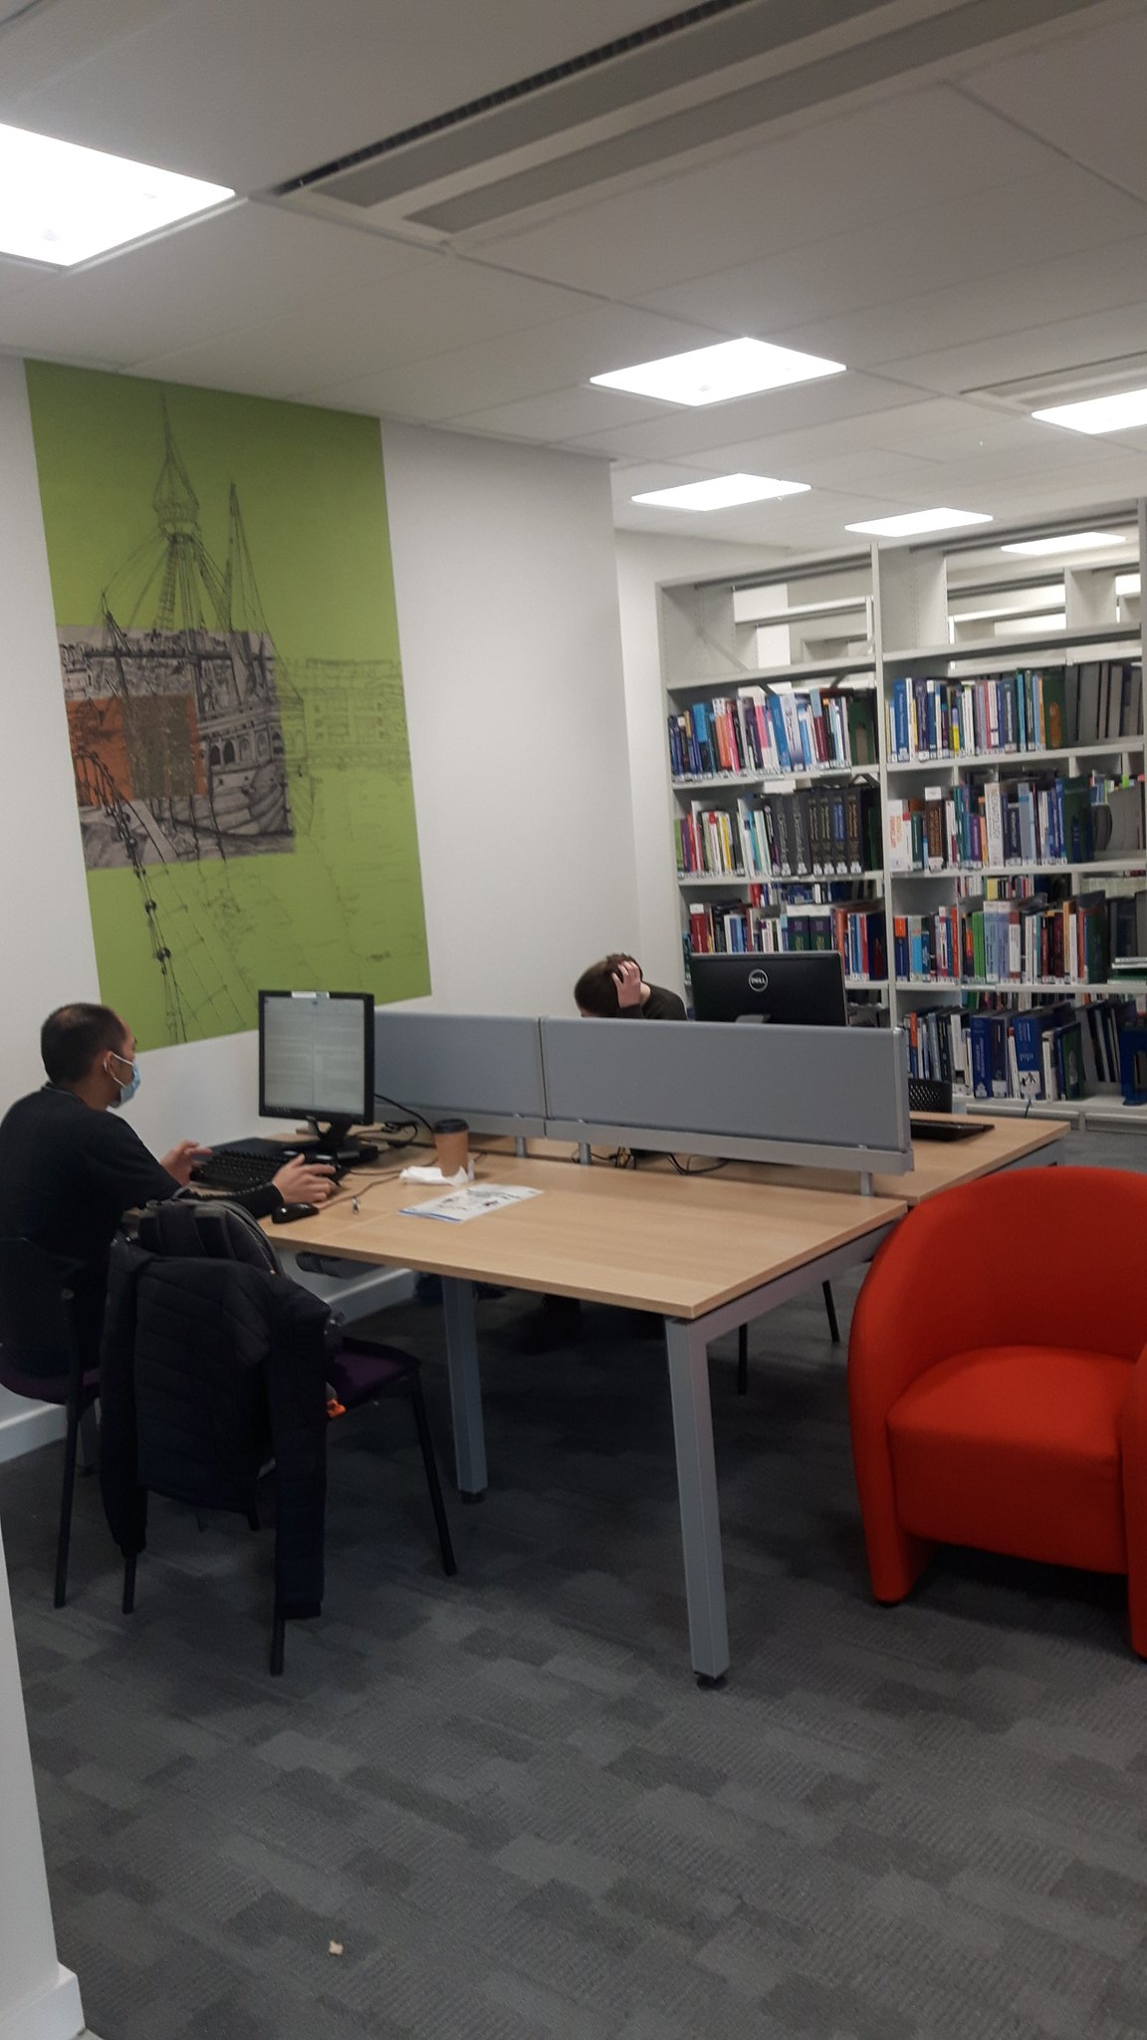
Lisa Malyon - https://www.lisamalyondraws.co.uk/

Last but not least something a little different. Lisa specialises in drawing and painting the built environment, and we opted to have some of her Bristol-specific works to grace the walls. She offers a service whereby her work is printed onto wallpaper and then applied directly to create a feature wall.

We wanted to celebrate Bristol‘s maritime heritage but felt the Clifton Suspension Bridge would have been a little too obvious a choice so instead opted for a couple of images from the harbourside. The fuschia pink is the Fairburn Steam Crane outside the M-Shed museum and the green Cabot’s ship the Matthew, usually moored nearby. All the feature wallpaper is created to individual order, so if you see something of Lisa’s work which catches your eye she may well be able to turn it into a feature wall.

It does feel like it it’s been a long time coming, but I have to say it’s worth the wait. The response to the new space has been overwhelmingly positive. Clearly social distancing is playing its part, and the library is currently limited to 15 rather than the planned 35 people, but hopefully by the end of this year things will be a little different. Either way, our giant kingfisher makes me smile every time I walk in the door.

John Loy
Library & Knowledge Services Manager,
North Bristol Trust (SMD)

[All images taken from Twitter]

Intra-lending is soon to launch…
but maybe you have a few reservations about Reservations?
Intra-lending – or Reservations – on V-Smart will ultimately make life easier for library staff and the end user and help to streamline your SWIMS Network ILL book request processes.

For example, procedures are made simpler by there being one system for ILL book requests – with username, item barcode and library ‘picklist’ all being on V-Smart – no need for duplication! The ‘picklist’ allows staff to check requests once or twice a day and deal with ILLs in ‘one go’ without responding to email notifications throughout the day, thus saving staff time.

Items are tracked at every stage of their journey. Plus it will work fine alongside WinCHILL and Clio (which will still be used for article requests) with no extra or duplicated work.

This is just for library staff in the SWIMS region for now, in the longer term we’ll make it available to end-users.

If you’re used to doing reservations for your own users, then it’s not much different!
Members of the ILDS group will be offering a package of support including videos, online procedures and 1:1/buddying help via Microsoft Teams.

Reservations is really the way to go
To streamline, reduce cost and improve ILL flow;
With username, barcode and library in one place,
You will find the new module really super ace!

The ILDS group will be there to lend a hand
To support and help you – we’re a merry band!
With instructions, buddying and even a video
You’ll be ready and sorted to give reservations a go!

With a picklist you check every day
It’ll soon become second nature - we pray!
Reservations will change our lives I’ll admit
But in a few weeks we’ll all be used to it!

Morag Evans, D08
Chair of SWIMS ILDS Group

#UKMedlibs: the February Chat

Join us for our February chat, 8 pm on Tuesday 16th February (which is also Shrove Tuesday – pancake tossing while chatting is encouraged, but not obligatory). Come and take part in a discussion of career progression and planning.

The questions for the chat are as follows:

- What does career progression/planning mean to you?
- What do new career entrants need to consider when moving up the ladder?
- How can people gain experience in areas not part of current job descriptions, e.g. line management?
- Is moving up always the right thing to do – is moving sideways more suitable? (or even down?!)
- Anecdotal evidence suggests that most people need to leave their current organisation to move on/up – is this true?
- How should managers encourage staff to consider career progress/planning?
- How would you encourage cross-sector career progression?
- What is your one piece of advice to those wanting to do something else?

Sam Burgess
#UKmedlibs volunteer
Library Service Manager.
Hampshire Healthcare Library Service (H05/H18/H34)
Gloucestershire Team - in 3 Counties and 2 Countries!

For us in Gloucestershire Hospitals working more from home has come with its advantages but also its challenges.

Initially when our working practices had to change we were a very disparate team (and some of us were desperate) due to redeployment and operating a completely virtual service, geographically we spanned 2 countries and 3 counties. It was not surprising there was a strong need to keep in touch with each other and have a grain of normality in our working day. Therefore we decided to maintain our daily 10.30am 15 minute tea break albeit now via Zoom. After several months, Zoom tea breaks every day felt more of a chore than a pleasure, we all know that meeting online is just not the same as having that in person connection, therefore we decided to try something different.

We currently now have a weekly team meeting and a weekly 30 minute tea break catch up called Chitty Chitty Chat Chat (don’t judge us names just arise organically). Our Chitty Chitty Chat Chat is where all work talk is banned and it is a time for us to reconnect with the things we would normally talk about if we were all working together in the office.

So far it is working well, however no doubt knowing us we will give it a few months and we will try something different! I reckon that we could do Friday Fancy Dress – what do you reckon Team GRH??? (I may not be popular with that suggestion! )

Lisa Riddington
Library & Knowledge Services Manager
Gloucestershire Hospitals NHS Foundation Trust (GRH/CGH)

Page 10

Editorial Team
Katie Barnard – Editor: Clinical Librarian, Learning & Research, Southmead Hospital (SMD): katie.barnard@nbt.nhs.uk

Sam Burgess – Editor in Chief: Library Service Manager, Hampshire Healthcare Library Service (H05): sam.burgess@southernhealth.nhs.uk

Pam Geldenhuys – Editor: E-Resources Librarian, Exeter Health Library (EXE): p.r.geldenhuys@exeter.ac.uk

Lucy Gilham – Editor: Knowledge Specialist, Hampshire Healthcare Library Service (H18) lucy.gilham@hhft.nhs.uk

Jessica Pawley – Editor: Librarian, Library, Musgrove Park Hospital (TAU): jessica.pawley@tst.nhs.uk

