Introduction to the Wessex Subject Headings
The Wessex Subject Headings can be used as an authority file for subject headings in library management systems, and they also act an index to the Wessex Classification Scheme. The terms in the Wessex Subject Headings are a subset of NLM’s Medical Subject Headings (MeSH) with additional local terms to reflect UK practice and terminology.
Most of the subject headings in Wessex are taken from MeSH but with British English spelling (e.g. PAEDIATRICS rather than PEDIATRICS). Where the subject heading differs from MeSH other than spelling, the scope note is prefixed with ‘Wessex MeSH’ to indicate that it has been added by the Wessex Classification Scheme Oversight Group.
The Wessex Subject Headings are managed by the Wessex Classification Scheme Oversight Group, and updates are published quarterly on the SWIMS website and in the Resource Discovery Digest. Suggestions for changes are always welcome and can be made via the SWIMS website.
Browing or searching the subject headings
The Wessex Subject Headings can be accessed at: https://taxonomy.hee.nhs.uk/WessexClassification.html
There are three different collections of headings (listed under Concept Scheme) - Wessex publication types, Wessex subheadings, and Wessex subject headings. The Wessex subheadings includes a list of all the subheadings (qualifiers) available for use with Wessex Subject Headings for those LMS that allow their use. The Wessex publication types include a list of all the publication type headings available in Wessex (for example, personal narratives or legislation). A search will cover all three collections.
Browsing
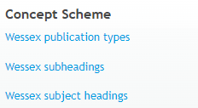
To browse the individual collections, click on the collection name, and then click on the ‘top concept’ name that appears.
You can also use the alphabet buttons below the search box to browse the collections, but these only show a small number of headings at a time.
To browse the entire set of Wessex Subject Headings, you can click on the ‘Wessex subject headings’ link (followed by clicking on ‘Subject heading’ under top concept). This will show the entire list of over 7,000 subject headings from A-Z.
Searching
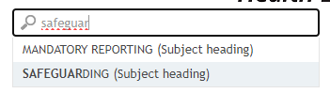
Doing a search will cover all three collections.
To search the headings, begin typing in the search box. The search function searches the main headings and any cross-references (so for example, typing ‘aspergers syndrome’ will bring up AUTISM).
As you type, you’ll see the first ten suggested headings – click on the one you want to look at (note: pressing enter will choose the first one on the list or the one your mouse is hovering over).
For some words there may be too many headings to display in the list (for example, neoplasms) so you may need to be more specific (e.g. stomach neoplasms or stomach cancer). If this still doesn’t provide you with the subject heading required, you may need to browse the entire list of subject headings.
Details screen
Once you’ve clicked on a suitable heading, you’ll see the details screen.
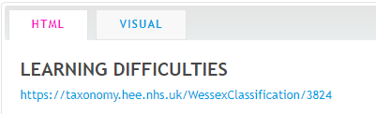
The details page give the term at the top, followed by the link to the page you’re currently viewing. The visual tab gives a visual rendering of the hierarchy of terms, but currently the Wessex Subject Headings are not placed in a hierarchy.
Alternative labels
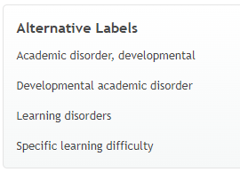
The alternative labels are terms added to help find the main term. In some cases, these correspond to the MeSH ‘used for’ field and aid in deciding whether a term is suitable.

Scope Note
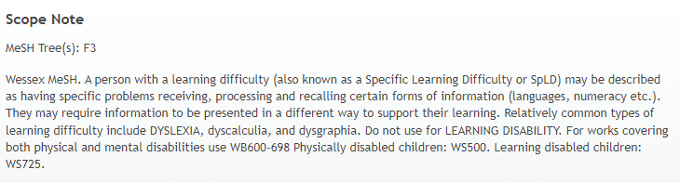
The Scope Note provides several pieces of information:
- Where the subject heading differs from MeSH, the scope note is prefixed with ‘Wessex MeSH’ to indicate that it has been added by the Wessex Classification Scheme Oversight Group

- The scope note definition may be adapted from MeSH, but will have British spelling (e.g. haematology instead of hematology) or it may be taken from another source (this is usually indicated after the definition) or it may have been created by the Wessex Classification Scheme Oversight Group

- Within the definition, terms in capitals are other subject headings
- Alternative classmarks may be suggested for a particular aspect of the topic or population group (for example, in children). See the ‘Definition’ field below for the main classmark.
- The MeSH tree is useful when deciding on any subheadings to apply (see subheadings section below) Note: As of April 2024, not all MeSH trees are displayed and you may wish to check the MeSH browser for a full list of trees.

Definition
In most cases this shows a suggested Wessex classmark.
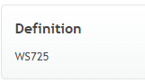
Always check the full Wessex Classification Scheme schedules (available at https://swimsnetworknhs.uk/how-to-guides/cataloguing/wessex-scheme/) to see if the item you’re cataloguing fits in the context of the classmark suggested.
For example, TRANSACTIONAL ANALYSIS, originally a psychotherapeutic technique used for mental disorder, is now used in a number of other settings and it would be inappropriate to classify these in the psychiatry (WM) schedules.
Within the scope note, alternative classmarks may be suggested for a particular aspect of the topic or population group (for example, in children).

Subheadings
Some LMSs allow the use of subheadings (qualifiers) in the subject field. For example, NEOPLASMS /diet therapy for a book about cancer and nutrition. Which subheadings are available for use with a particular subject heading is determined by the MeSH Tree that the heading sits under.
The list of subheadings available for use in Wessex is available in a separate collection that can be accessed from the front page of the Wessex Subject Headings (you can also search them from the main search box as well).
For example, if the MeSH Tree given in the scope note is C4, then you can check the list of subheadings, and see that /diet therapy is available for use. In this case /diet therapy can be used in any C tree so can be used on terms in the MeSH Tree C4.
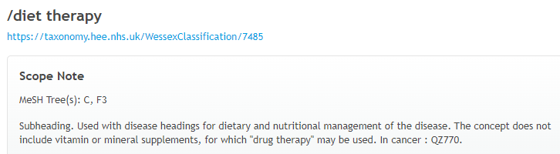
Some useful subheadings may also be suggested in the scope note.
Broader Concepts
Currently, Wessex is not arranged in a hierarchy like MeSH. In time it is hoped to use the MeSH hierarchy to arrange Wessex by broader and narrower topics, but at the moment the link to ‘Subject heading’ in the Broader Concepts section simply links to the A-Z listing of Wessex Subject Headings.
Related concepts
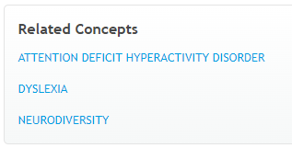
These are suggestions for other related subject headings that may be useful. Clicking the links will take you to the subject heading.

We would like to acknowledge the guidance of the National Library of Medicine. NLM have asked us to make it clear that the Wessex Classification Scheme is not an official NLM revision of its classification scheme and it is the product of the local efforts of UK health librarians. The National Library of Medicine neither endorses nor supports the Wessex Classification Scheme.

